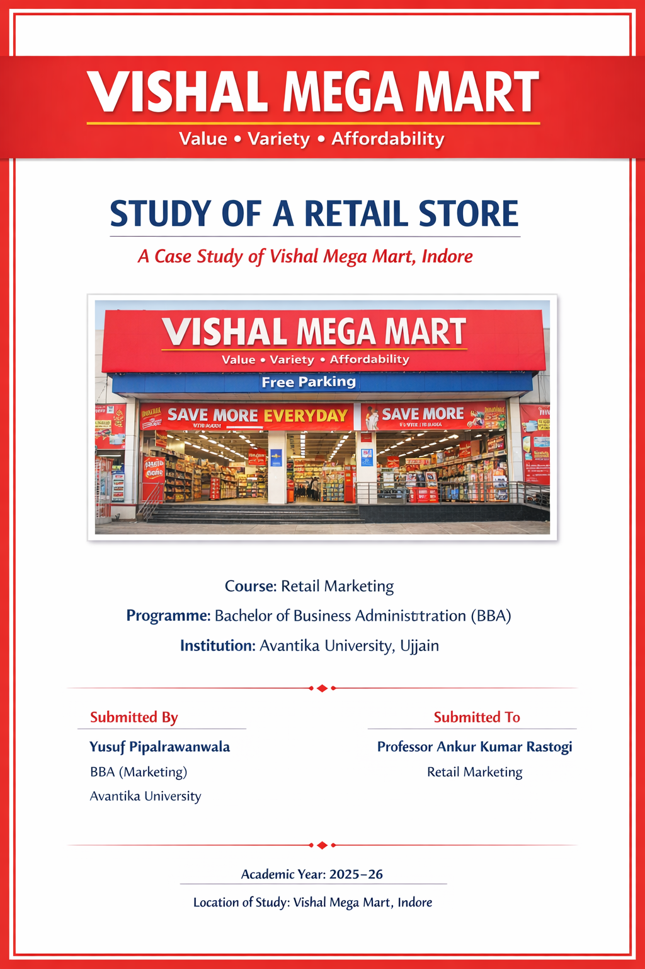

- Introduction:
- Retailing is an important activity in linking the manufacturers to the final consumers. A retail store, however, that is not only a place of transaction but an atmosphere that involves the effects of price, product presentation, promotions, and customer service that may combine to influence buying behavior. Learning how a retail store operates in real life, the students learn to connect theory with practice.

- This project is based upon a physical visit and observation in Vishal Mega Mart, Indore which is a popular value retail chain in India. Vishal mega mart works on the discount retail model, emphasizing economy, mass consumption, and high sales volume. The store enjoys a diverse customer base, particularly the middle class and lower class, by having daily necessities and clothing items on sale at good prices.

- The research aims to analyze the manner in which Vishal Mega Mart handles the assortment of the products and store layout, promotions, pricing strategy, and customer services and the extent to which it contributed in the success of the retail store.

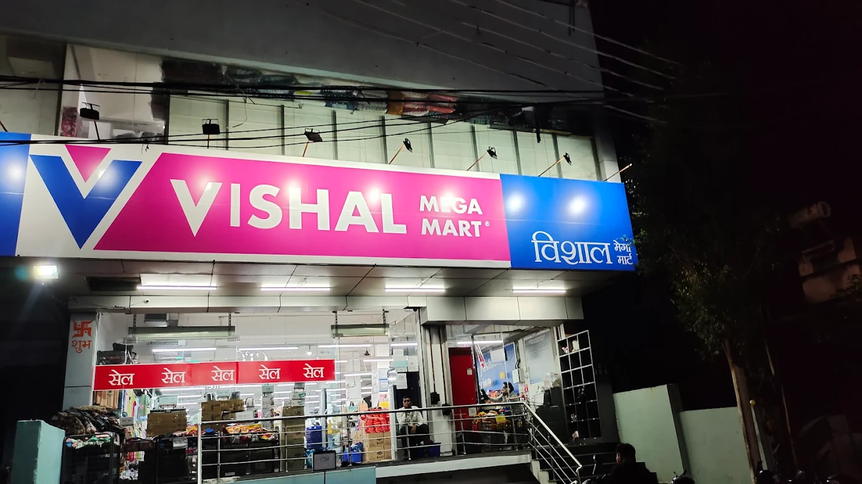

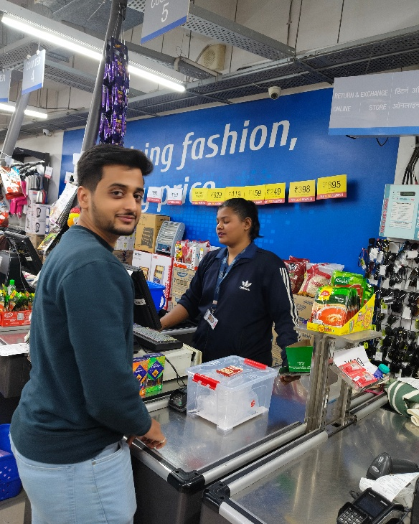

- Store Profile:
- Store Name: Vishal Mega Mart
- Location: Indore, Madhya Pradesh
- Type of Store: Physical retail store
- Retail Format: Value / Discount Store
- Nature of Business – Vishal Mega Mart is based on the self-service retail model where the customer can browse freely for the products without the constant help of the staff. The focus is on high product availability, low pricing and quick turnover rather than premium shopping experience. The store layout and operations suggest a cost leader strategy that is aligned with the brand positioning of Vishal Mega Mart as an idea of affordable retail.

- Products and Services Offered:
- Product Mix Analysis:
The store has a wide and deep range of products which makes it a one-stop shop for households.
Product Category | Description
Apparel | Men’s, women’s, and kids’ clothing
FMCG Products | Packaged food, snacks, beverages
Home Essentials | Kitchenware, storage containers
Personal Care | Soaps, shampoos, grooming items
Footwear | Slippers and basic footwear
Seasonal Items | Festival-related and weather-based products
This huge mix of items boosts customer footfall and induces cross-cat purchases.
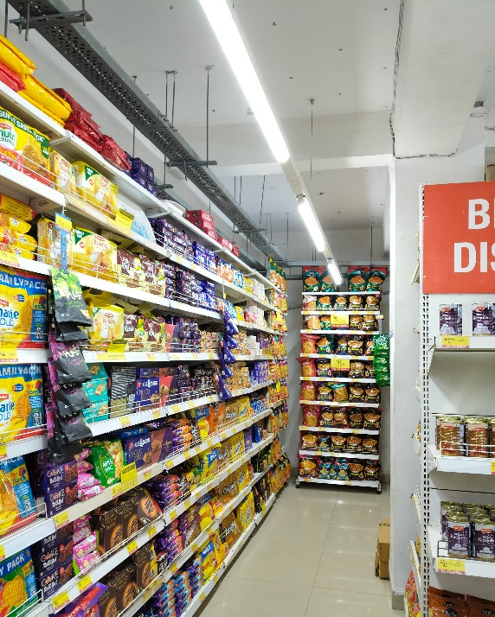

- Services Provided:
Although the primary concern of Vishal Mega Mart is based on products, it provides a number of essential services:
- Easy accessibility of product through wide aisles
- Costs Inexpensive Prices Grouped
- Multiple payment options (Cash/ UPI/debit/credit Card)
- Seasonal sales and offers that are regular
For example, the store does not focus on providing premium services but provides basic convenience and efficiency which is suitable to its target market.

- Store Layout and Visual Merchandising:
- Store Layout: The store in question uses a grid layout, that is common in supermarkets and discount stores.
- Key Features of the Layout:
- Aisles that are straight for easy navigation
- Category wise arrangement of products
- Apparel sections that are placed in visible areas
- Billing counters placed close to the exit
This layout is useful for customers in locating products fast, and also for the high volume of sales.
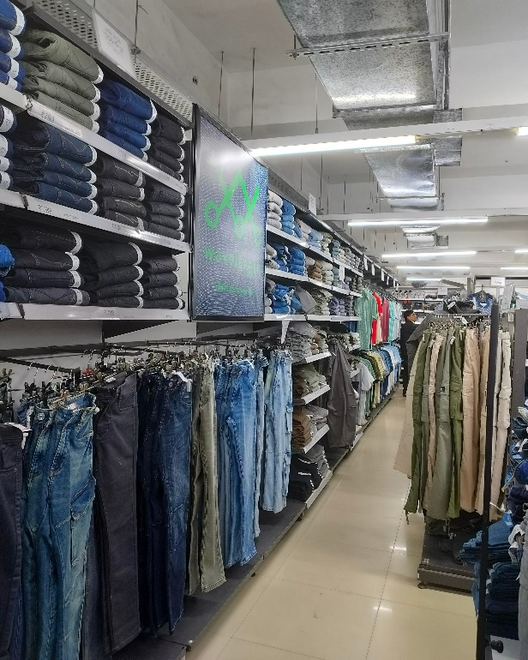

- Visual Merchandising: Visual merchandising at Vishal Mega Mart is functional as opposed to aesthetic.
- Price tags which are clearly visible
- Products are stacked in bulk Discount labels take the dominance of visual appeal
- Little use of mannequins / premium displays
This is a way to reinforce the value for money image of the store as well as attract the price conscious shoppers.

- Pricing Strategy and Promotions:
- Pricing Strategy: Vishal Mega Mart is following the low price and high-volume pricing policy.
- Products are priced at a lower level than many competitors
- Focus on affordability
- Glass instead of premium margins
- Attractive pricing so that they visit again
This strategy helps Vishal Mega Mart have a very good scale of sales, even in highly competitive markets.
- Promotional Activities:
Promotion Type | Observation
Discount Boards | “Save More”, “Best Price” signage
Festive Offers | Increased discounts during festivals
Combo Deals | Buy more, save more offers
In-store Banners | Promotional posters and boards
Promotions mainly focus on price visibility, which directly influences impulse buying.
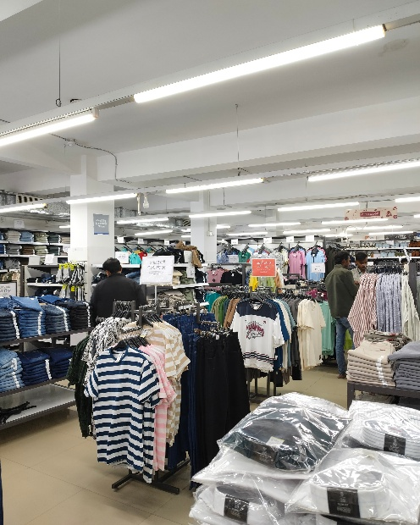

- Customer Service and Billing Process:
- Staff Behaviour:
- Staff members were polite and responded to when approached
- Limited interaction unless she or he asked for help
- Personnel availability in the area of billing and apparel sections
This is reflective of the self-service retail approach because of a reduction in operational costs.
- Billing and Checkout:
- Centralised POS billing counters
- A number of counters to control heavy footfall
- Fast and efficient billing process
Efficient checkout leads to reduced customer frustration and, as a result, to increased customer satisfaction.
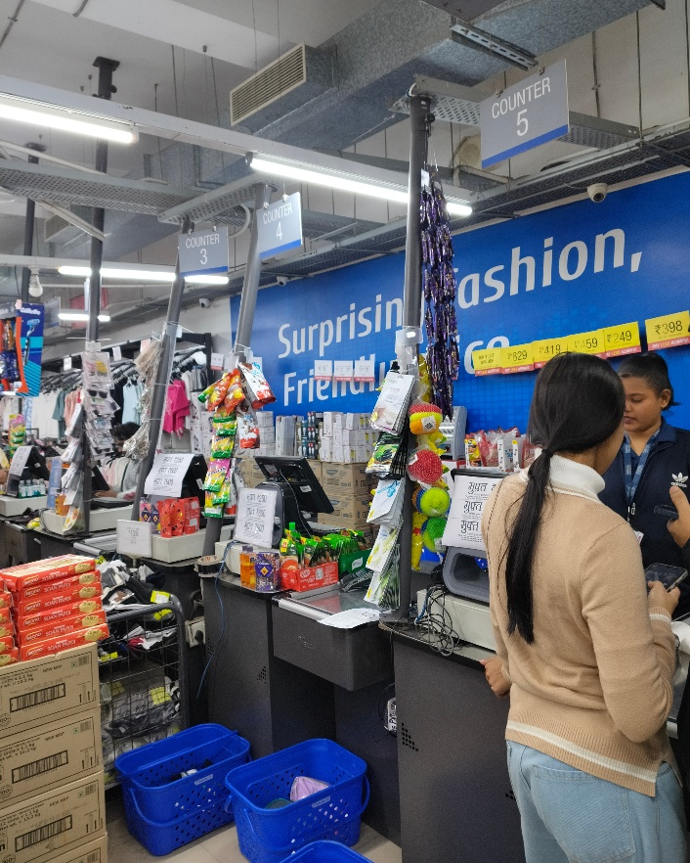

- Customer Journey Analysis:
Stage | Observation
Entry | Promotional boards attract attention
Browsing | Easy movement due to wide aisles
Selection | Pricing influences quick decisions
Billing | Organized POS counters
Exit | Satisfaction due to savings

This journey emphasises how Vishal Mega Mart's second priority is utility and affordability and not on experience.

- SWOT Analysis:
Strengths | Weaknesses
Affordable pricing | Limited premium appeal
Wide product range | Basic store ambiance
Strong brand presence | Less personalized service

Opportunities | Threats
Expansion in tier-2 cities | Competition from D-Mart
Growth in private labels | Online discount platforms

- Learning and Managerial Insights:
- Key Learning:
- Retail Success Relied on Target Markets
- Understanding Value pricing can promote high customer loyalty
- Product Placement, and How It Affects Impulse Buying
- What I Liked:
- One stop shopping convenience
- Affordable pricing
- Clear categorization of product
- Suggestions For Improvement:
- Improved lighting on apparel section
- Improved visual merchandising
- Increased staff at peak hours

- Conclusion: The study of Vishal Mega Mart, Indore gave useful knowledge regarding working of a value retail store on the shop floor. The store basically implements marketing strategies in retail like affordable pricing, efficient layout, and effective promotions for attracting the masses. This project helped me gain better knowledge of real-world retail operations and it was helpful to relate theoretical information to actual observation.

